**Graded Assignment on Automated Testing and Linux and Shell Scripting :**

Git Repository link : <https://github.com/igSpanser/Test.git>

Profile link : <https://hvdevops.prashantdey.in/users/Shrutika> Panchal

1. Read File :

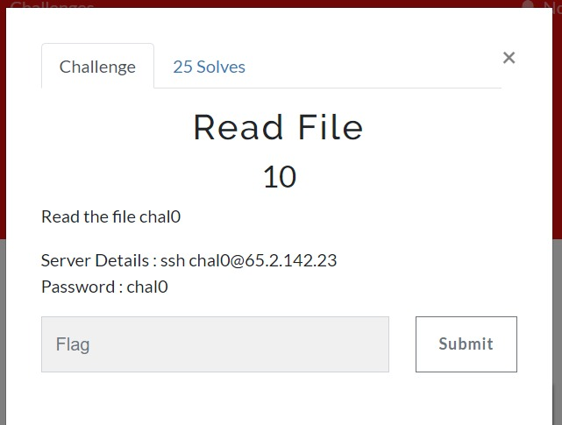

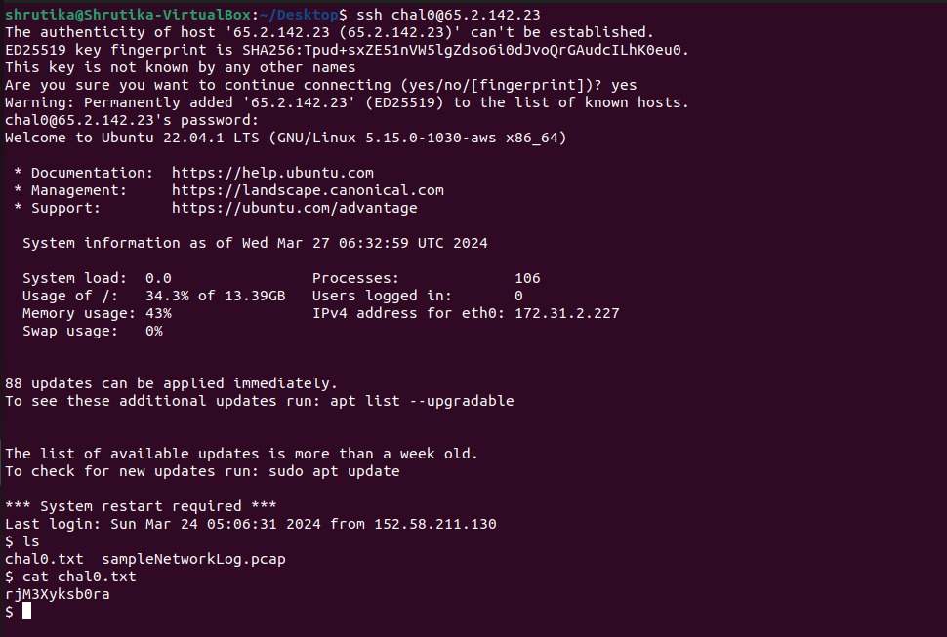

Flag : rjM3Xyksb0ra

1. Hidden Files :

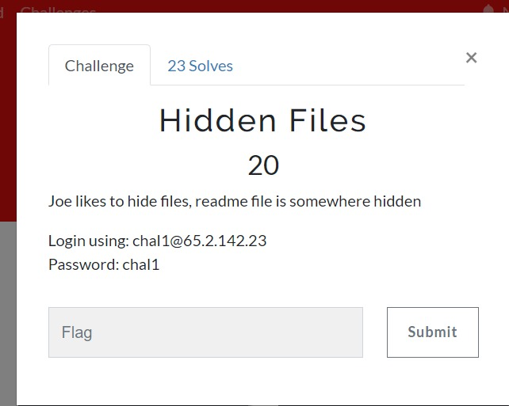

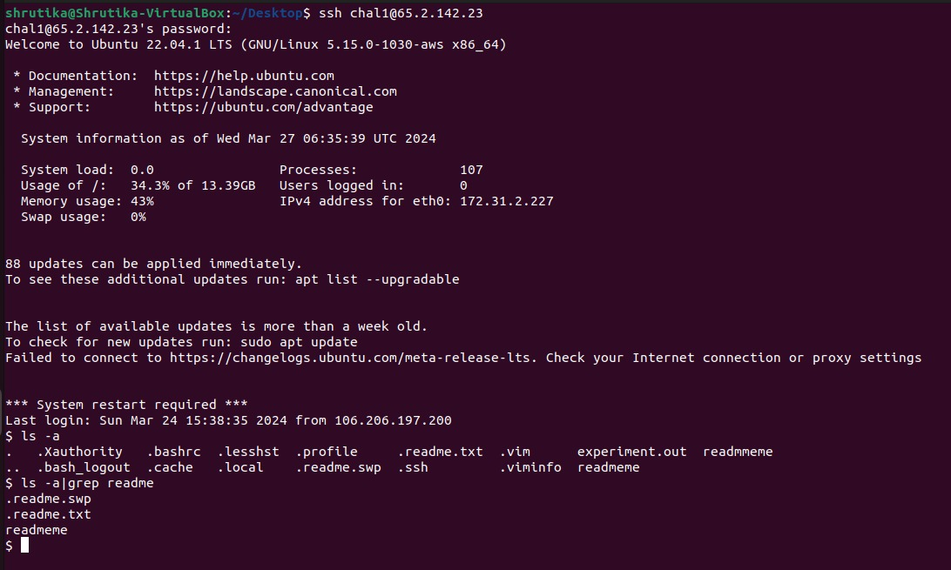

Flag : djKz2b3XNh8l

1. Unique Flag :

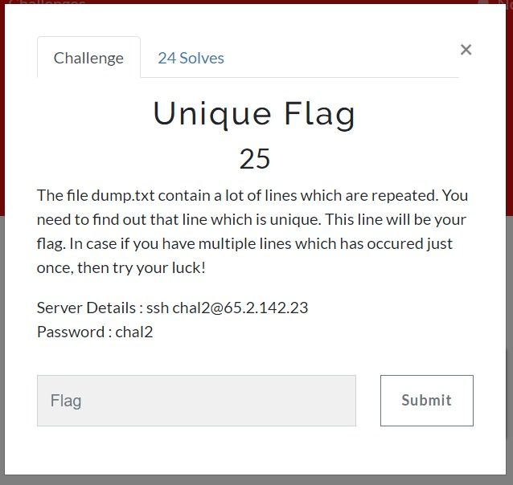

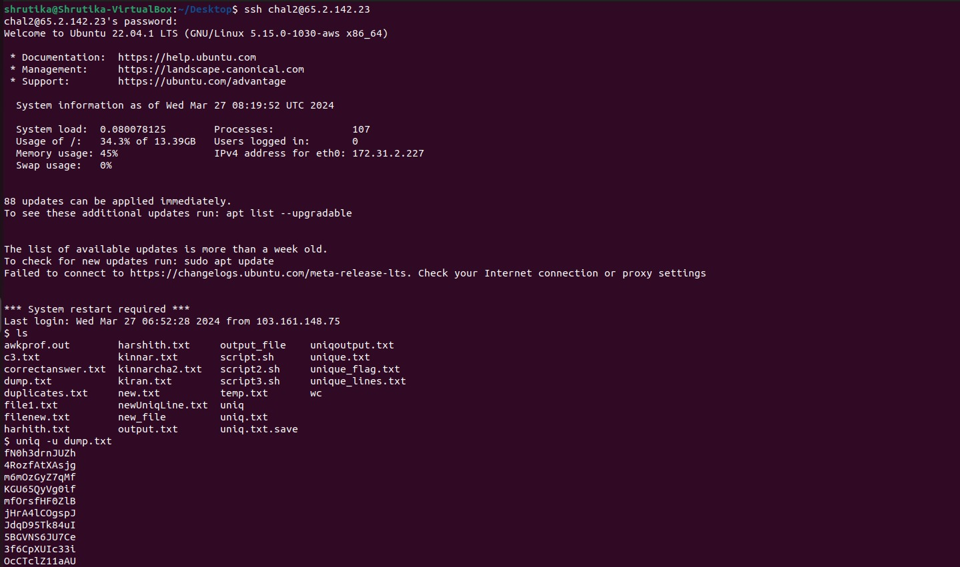

Flag : YW8mKZYXh4UT

1. Pain in a Dash :

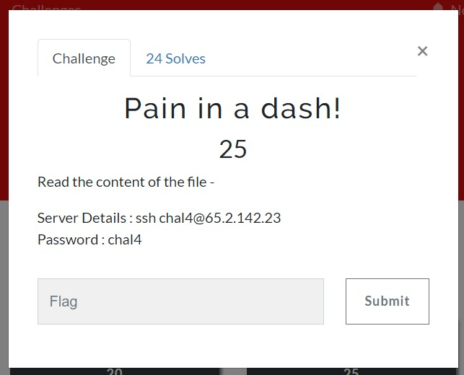

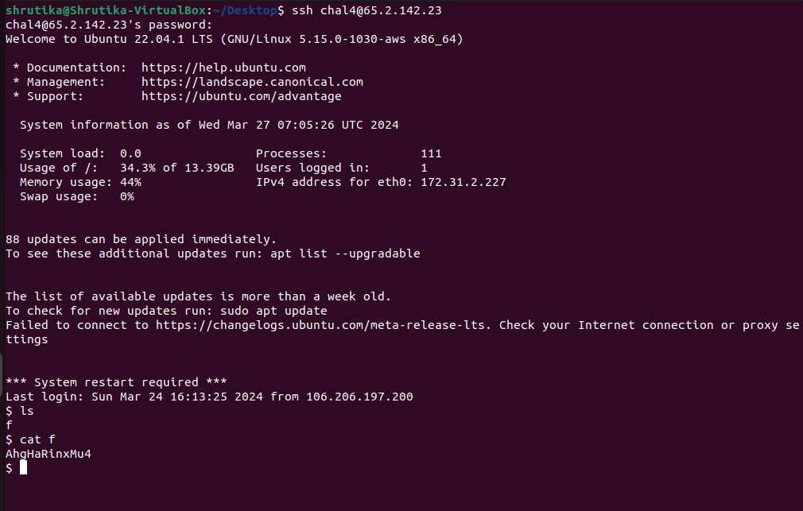

Flag : AhgHaRinxMu4

1. Eleven :

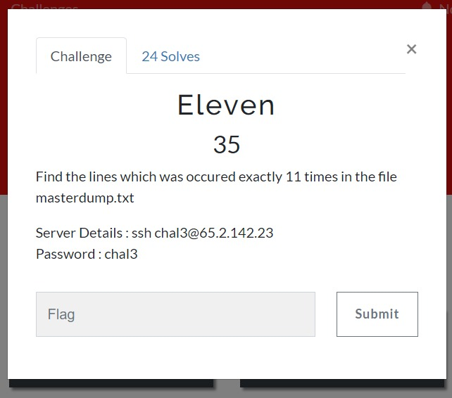

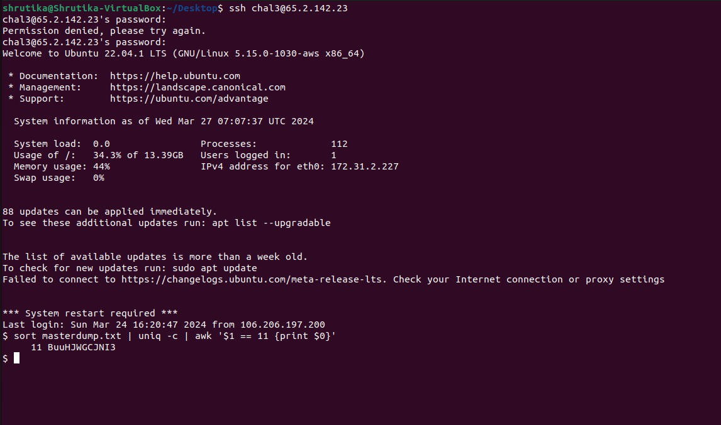

Flag : BuuHJWGCJNI3